Blewbury Parish Council
Clerk to the Council
Mrs K Lloyd
Butlers, Church Corner
Yattendon, Berkshire, RG18 0UP
blewburypc@gmail.com
07968 772935

MINUTES of the Annual meeting of the Parish Council held on Wednesday 21st May 2025 at 7.00 pm in the Melland Room at the Blewbury Clubhouse.

In attendance:
Cllr. Anne Millman (chaired this meeting)
Cllr. Lee Robinson
Cllr. Shelia Austin
Cllr. Julia Saunders
Cllr. Mark Shayler
Cllr. Andy Evason
Cllr. Dermot Mathias, from 8.15pm
Iain Wood, Lengthman
Parish Clerk. Kim Lloyd
District Councillor: Hayleigh Gascoigne
2 x Members of the public, Mr & Mrs Watt

In the absence of Dermot, Anne was proposed by Julia and seconded by Shelia to chair this meeting. All in agreement.

1. Election of Members
1.1. Nomination and election of Chairman, Dermot Mathias was proposed to remain as Chair, by Shelia, Julia seconded, all agreed.
1.2. Nomination and election of Vice-Chairman, no nominations were received. This was decided to defer to a later meeting.

2. Apologies for Absence
Apologies received from Andrew Calder, Lydia Inglis and District Councillor Rebekah Fletcher. Dermot said he would try and arrive later during the meeting.

3. Declarations of Interest - No declaration of interests were received.

4. Public Participation
Nothing raised.

Planning Matters

5. Planning Updates
5.1. Thanks were given to Lydia for preparing the 2024/25 Planning Report which was circulated to Council before the meeting. The report will be published on the website apart of the Annual Parish Meeting Mins.
5.2. The following new Planning Applications were reviewed.

- P25/V0314/DIS Rumseys Barn London Road Blewbury. Discharge of conditions 5(Surface Water Drainage), 6(Foul Water Drainage) and 7(Tree Protection) on application P22/V0669/FUL. (Updated drainage information received 7 April 2025) (Demolition of existing garage and swimming pool building; construction of new dwelling). Parish Council resolved to no comment.
- P24/V2404/HH. Millbrook Cottage Berry Lane Blewbury OX11 9QJ. Retrofitting of energy efficiency measures including the installation of an Air Source Heat Pump and solar PV panels in the rear garden. (Additional plan showing route of the cable conveying power from the solar panels to the main dwelling received 11th March 2025) (Additional plan showing the route of the cabling received 4th April 2025) (Construction Method Statement received 4th April 2025). Parish Council resolved to no comment.

- P25/V0953/FUL. Ashbrook House Westbrook Street Blewbury OX11 9QA. Proposed self-build single-storey (with rooms in the roof) detached one and half-bedroom dwelling. Parish Council resolved not to object but request a condition is imposed – as suggested by the applicants – to prevent future development on this site via the suspension of usual permitted development rights.
5.3. Planning Decisions from Vale of White Horse DC – for information only.

- P24/V2671/HH. St Michaels Church Road Blewbury OX11 9PY Demolition of existing rear porch. New single-storey rear and side extensions. Internal and external works to Listed Building. Demolition of garage (as amended by plans and additional information received 26 February and 19 March 2025).
VOWH granted permission. BPC no objections.

- P18/V1826/RM GWP Healthcare Site Sir Frank Williams Way Harwell.
Reserved Matters application following Outline approval P02/V1594/O for Mixed-use urban extension of 3300 new dwellings together with associated open space, leisure, community, local shops and services and drainage and utility infrastructure. Consent sought for: Erection of Healthcare Centre, car parking, landscaping and associated infrastructure.
VOWH granted permission. BPC supported.

- P25/V0264/S73. Oak Hall House Nottingham Fee Blewbury OX11 9PG. Variation of condition 2 (approved plans) on application ref. P24/V1678/HH – to add 0.5m to depth of approved extension (Replacement of existing glass room with single storey rear extension)

VOWH granted permission. BPC no objections.

- P25/V0338/HH. 19 London Road Blewbury Didcot OX11 9NX. Two storey rear extension and front porch. (Amended plans received 3rd March 2025- Omitting proposed flue) (Amended plan received 11th April 2025- Changing the cladding to render)

VOWH granted permission. BPC no objections.

- P24/V2404/HH. Millbrook Cottage Berry Lane Blewbury OX11 9QJ. Retrofitting of energy efficiency measures including the installation of an Air Source Heat pump and solar PV panels in the rear garden. (Additional plan showing route of the cable conveying power from the solar panels to the main dwelling received 11th March 2025) (Additional plan showing the route of the cabling received 4th April 2025) (Construction Method Statement received 4th April 2025)
- VOWH grants permission. BPC no objections.

- P24/V2405/LB. Millbrook Cottage Berry Lane Blewbury Didcot OX11 9QJ
Retrofitting of energy efficiency measures including the installation of an Air
Source Heat Pump and solar PV panels in the rear garden.
(Additional plan showing route of the cable conveying power from the solar
panels to the main dwelling received 11th March 2025)
(Additional plan showing the route of the cabling received 4th April 2025)
VOHW granted permission. BPC no objections.

Reports & Updates

6. County Councillor
Update received from the County Councillor and circulated.

7. District Councillor
The Annual Report from the District Councillor was received and circulated to Council The report will be published on the website apart of the Annual Parish Meeting Mins. Congratulations were given to Hayleigh Gascoigne for being re-elected following the May elections.
It was noted that 30th June was the deadline for climate funding applications.

8. Actions from previous meeting
Item 8, April Mtg - Lee moved the electricity provider to Octopus from Scottish Power to enable a meter to be installed in the Clubhouse. Wating on Octopus to look into this.
Item 9.2, April Mtg - Andy reported that the mirror is ordered and will investigate on how to mount mirror. Mark said he could help with this.
All other actions were completed.

9. Clubhouse & Recreation Ground

9.1 The Report from Evi Holroyd on March Clubhouse bookings was received with no further comments raised. A meeting on 16 June with Shelia (new chair), Dermot, Ann and Evi has been arranged.
9.2 Business Rates: Old Scout Hut / Clubhouse, a report was provided from Dermot.
Item 9.2 Old Scout Hall and Clubhouse Business Rates Update
An online meeting with Dermot, Hayleigh, two officers from the VOWH and two from Capita. It was confirmed that no rates are payable on either the Clubhouse or Scout Hut. The reason is that the Scout Hut should be treated as a separate building (because it is occupied by Blewshed) and is therefore entitled to small business relief.
Mike Magnay from Blewshed, along with the Clerk completed forms for both the Scout Hut and Clubhouse, the forms have been submitted to VOWC. BPC await the outcome. Hayleigh and Dermot was both thanked in dealing with this matter.

10. Lengthman’s Report – I. Wood
10.1. Vandalism during Easter (TTF bike track, signs, swing)
Since reported vandalism during the Easter holidays, no other issues have occurred. The Clerk sent a report to the police and requested police patrols in the area. Signage had been removed though the vandalism. The Clerk will look at replacing the missing sign.
10.2. Big Stepper and KAP slide steps repair update, Mark and Iain were thanked for carrying out the repairs. Mark raised the action that a maintenance budget plan needed to be in place for future work in all play equipment play areas.
The chain on the big swing needs to be inspected every 6 months, and the bolt annually. This needed to be added to the internal inspection check list for Iain to check periodically.
10.3. Cemetery bins. It was reported that an extra waste bin had been found in the cemetery. The Clerk will monitor the collection to ensure BPC are not charged extra.
10.4. Quaker Wood first cut report. Iain was thanked for his work on the first cut, which needed a lot of initial work. Iain had recorded his time spent on this, to pass to the Clerk for invoicing Sustainable Blewbury.

Mark proposed funds for materials to make a new picnic bench to replace the one that was in TTF. Council resolved to up to £500 towards the expenditure. Mark will confirm exact cost when known.
Thanks were given to both Iain and Mark for all their hard work.

11. Parish Benches (AC)
To consider Iain auditing benches and maintaining part of maintenance schedule
This was deferred to the next meeting as Andrew was not present.

12. Traffic & Safety
12.1. The Speed Data Report for March/April (Wendy Carless) was received and circulated to the Council, with no further questions raised. The report will be published on the website as part of the Annual Parish Meeting minutes. Matthew Barber, Thames Valley Police & Crime Commissioner, had confirmed his attendance at the Annual Parish Meeting, where he will be engaged in discussions regarding speed enforcement.
12.2. Vision Zero representative update (AM) No further update at this time.

13. Environment
13.1. Flooding and Drainage. Andy reported that the work carried out in Church End by the local authority officials was completed in the wrong location, missing the suspected source of the flooding. As a result, Andy and Anne have requested a second opinion from Oxfordshire County Council (OCC).
13.2. Sustainable Blewbury (SB) Anne reported that on the 22nd June 2025 12-3pm the opening of the new community wood event will take place. Blewbury Village Society will be running a bar. Official opening at 2pm when SB will thank everyone who has made the wood possible.
Quaker Wood is along the concrete path on the right, north of the village hall in Heather Way. Park in the village hall car park. See SB website for more details.
13.3. Other areas. Shelia reported ongoing flooding issues at Ladycroft park. Anne requested that Shelia keep both her and Andy updated so they can consolidate all related concerns when presenting them to OCC.

Administrative Items

14. Approval of Minutes
The Minutes of meeting held on 16th April 2025 were approved.

(Dermot arrived at 8.15pm)

15. Finance
15.1. The May payments were approved. Appendix 2.
15.2. The bank reconciliation as of 30th April 2025 was approved, Appendix 2

16. Annual Approvals
16.1. Standing Orders
16.2. Financial Regulations
16.3. Risk Management
All documents were approved to adopt for the forthcoming year, with only one small amendment to the Risk Management policy raised by Lee, which the Clerk will amend.

17. Asset Register
It was noted that the Asset Register for 2025–2026 needs working on. This will be deferred to a later meeting.

18. General Power of Competence
All councillors approved to retain the General Power of Competence and confirmed that criteria were met.

19. Councillor Responsibilities
The responsibilities were updated for 25-26, see Appendix 3.

Committee & Working Group Membership

20. Committees – Confirm Members
• Finance: DM, AC, LR, AM, this remains as it stands
• HR: AM, DM, LI – Julia will replace Lydia (LI)

21. Working Groups – Confirm Members
• Clubhouse: AM, DM, HEH, SA, this remains as it stands.

Projects & Ongoing Matters

22. Skatepark Tenders
The Skatepark Working Group is continuing to explore quotes for the construction of a concrete skatepark. As part of their research, the group is visiting neighbouring parishes to assess their skatepark ramps and gather insights that could inform plans for Blewbury.
The Council extended its heartfelt gratitude and commendation to the late Michael Pennington for his generous donation of £50,000 towards the skatepark renovation.

23. Graffiti – London Road Bus Shelter
Council gave a Thank you to Geoffrey Mark for painting over the graffiti in the bus shelter.

24. Grahame Close EV Point
It was noted that the Council is still exploring the installation of EV charging points at the village hall. Regarding EV points at Grahame Close, the resident who had expressed interest in pursuing this would need to liaise with local authorities to obtain approval for installation in that location. As ownership of the site remains unclear, the Parish Council supports this initiative but encourages the resident to make inquiries with local authorities to determine its feasibility and to keep the Parish Council updated.

25. Tennis Club
25.1 Lease update following club meeting on 08/05. The lease was reviewed, and the Tennis Club committee will send proposed amendments to Council. A £500 contribution to the Parish Council was suggested and will be discussed at their next committee meeting. They have requested a list of relevant maintenance items, including litter removal, car park and drainage maintenance, shrub cutting, and border planting.

25.2 Update on shrubs for planting along the fence between the courts and the carpark. Dermot and Anne met with the Chair and Secretary of the Tennis Club to discuss court resurfacing, noting that CIL funds must be allocated to essential items. Alternative funding sources are being investigated.

26. Armillary Sphere – Play Close. Mark is overseeing the installation process. There are no further updates on the sphere's launch until the Council confirms its expected installation date. In the meantime, Mark will keep Julia informed, as Julia will be working on the launch wording.

27. Permissible Footpath Closure

Dermot and Julia confirmed they will meet with the landowner to discuss the footpath.

28. Chailey Gardens playground Trinity

Email 24/04 from Trinity Estates confirmed that they are aware of work needed and quotes are being sought. The Clerk will continue to pursue.

29. Annual Parish Meeting – 22nd May 2025

The Clerk provided an update of groups attending. The mins of Annual Parish Meeting including shared group reports will be published on the website following the meeting.

Correspondence & Reports

30. Clerk’s Correspondence
No further correspondence not otherwise covered on Agenda.

31. Chairman’s Report
Dermot had circulated his report for the Annual Parish Meeting.to Council who were happy for the report to be read out at Annual Parish Meeting. This will be included in the Annual Parish Meeting minutes shown on website.

32. Councillors’ Reports
No updates from Parish Councillors that was not listed on agenda.

33. Future Agenda Items
• Neighbourhood Plan Review – July/September

34. Date of Next Meeting

Wednesday, 18th June 2025

Appendix 1

Actions
Item | Mtg | Action | Ownership
13 | April | Repair to Zip Wire | Iain /Mark
9.2 | April | Blind spot mirror | Andy Evason
8 | April | Clubhouse, meter installation. | Lee and Andy Evason
10.2 | May | Play equipment future Maintenance Budget Plan | Clerk/Mark/Iain
10.2 | May | Add Big Swing parts to internal inspection sheets | Clerk
16.3 | May | Amend RA | Clerk
10.1 | May | TTF Sign replacement | Clerk
17 | May | Update Asset Register | Andrew/Clerk

APPENDIX 2

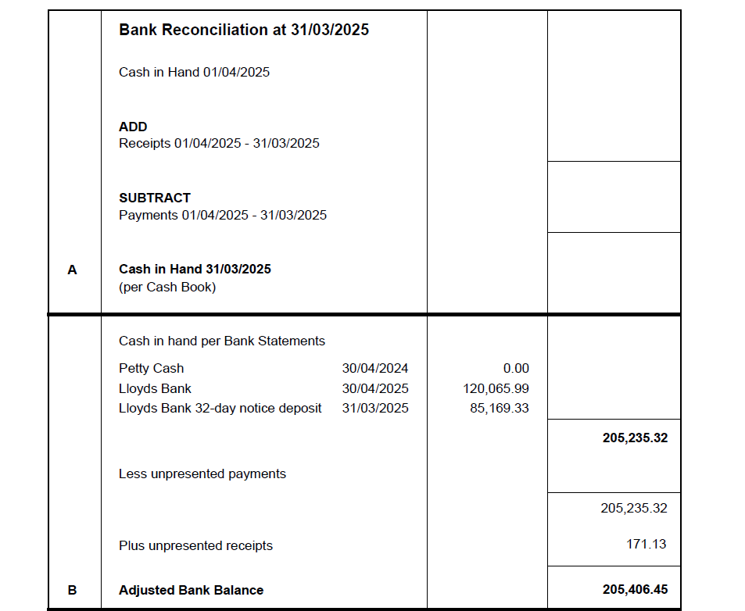

APPENDIX 3

